# Database Basics MS SQL Exam – 12 Feb 2023

Exam problems for the ["Database Basics" course @ SoftUni](https://softuni.bg/trainings/3965/ms-sql-january-2023)

Submit your solutions in the SoftUni Judge system at [Judge](https://judge.softuni.org/Contests/3888/Databases-MSSQL-Server-Exam-12-Feb-2023)

# Section 1. DDL (30 pts)

You have been given the E/R Diagram of the **Boardgames** database.

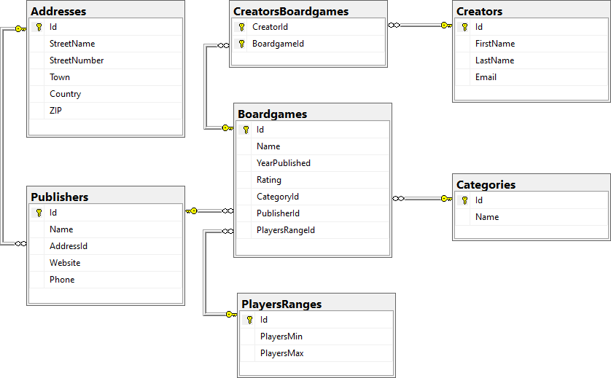

Create a database called **Boardgames**. You need to create **7 tables**:

* **Categories**  – contains information about the boardgame's category name;
* **Addresses** – contains information about the addresses of the boardgames' publishers;
* **Publishers** – contains information about the boardgames' publishers;
* **PlayersRanges** – contains information about the min and max count of players for each game;
* **Creators**– contains information about the creators of the boardgames;
* **Boardgames** – contains information about each boardgame;
* **CreatorsBoardgames** – mapping table between creators and boardgames.

**NOTE: Keep in mind that Judge doesn't accept "ALTER" statement and square brackets naming (when the names are not keywords).**

You have been tasked to create the tables in the database by the following models:

##### ****Categories****

|  |  |  |
| --- | --- | --- |
| **Column Name** | **Data Type** | **Constraints** |
| **Id** | **Integer** from **0** to **2,147,483,647** | PK, Unique table identification, Identity |
| **Name** | **String** up to **50** symbols | **Null** is not allowed |

##### ****Addresses****

|  |  |  |
| --- | --- | --- |
| **Column Name** | **Data Type** | **Constraints** |
| **Id** | **Integer** from **0** to **2,147,483,647** | PK, Unique table identification, Identity |
| **StreetName** | **String** up to 100 symbols, Unicode | **Null** is not allowed |
| **StreetNumber** | **Integer** from **0** to **2,147,483,647** | **Null** is not allowed |
| **Town** | **String** up to **30** symbols | **Null** is not allowed |
| **Country** | **String** up to **50** symbols | **Null** is not allowed |
| **ZIP** | **Integer** from **0** to **2,147,483,647** | **Null** is not allowed |

##### ****Publishers****

|  |  |  |
| --- | --- | --- |
| **Column Name** | **Data Type** | **Constraints** |
| **Id** | **Integer** from **0** to **2,147,483,647** | PK, Unique table identification, Identity |
| **Name** | **String** up to **30** symbols | Unique, **Null** is not allowed. |
| **AddressId** | **Integer** from **0** to **2,147,483,647** | Relationship with table **Addresses**, **Null** is not allowed |
| **Website** | **String** up to **40** symbols, Unicode | **Null** is allowed |
| **Phone** | **String** up to **20** symbols, Unicode | **Null** is allowed |

##### ****PlayersRanges****

|  |  |  |
| --- | --- | --- |
| **Column Name** | **Data Type** | **Constraints** |
| **Id** | **Integer** from **0** to **2,147,483,647** | PK, Unique table identification, Identity |
| **PlayersMin** | **Integer** from **0** to **2,147,483,647** | **Null** is not allowed |
| **PlayersMax** | **Integer** from **0** to **2,147,483,647** | **Null** is not allowed |

##### ****Boardgames****

|  |  |  |
| --- | --- | --- |
| **Column Name** | **Data Type** | **Constraints** |
| **Id** | **Integer** from **0** to **2,147,483,647** | PK, Unique table identification, Identity |
| **Name** | **String** up to **30** symbols, Unicode | **Null** is not allowed |
| **YearPublished** | **Integer** from **0** to **2,147,483,647** | **Null** is not allowed |
| **Rating** | **Decimal** number with two-digit precision | **Null** is not allowed |
| **CategoryId** | **Integer** from **0** to **2,147,483,647** | Relationship with table **Categories**, **Null** is not allowed |
| **PublisherId** | **Integer** from **0** to **2,147,483,647** | Relationship with table **Publishers**, **Null** is not allowed |
| **PlayersRangeId** | **Integer** from **0** to **2,147,483,647** | Relationship with table **PlayersRanges**, **Null** is not allowed |

##### ****Creators****

|  |  |  |
| --- | --- | --- |
| **Column Name** | **Data Type** | **Constraints** |
| **Id** | **Integer** from **0** to **2,147,483,647** | PK, Unique table identification, Identity |
| **FirstName** | **String** up to **30** symbols, Unicode | **Null** is not allowed |
| **LastName** | **String** up to **30** symbols, Unicode | **Null** is not allowed |
| **Email** | **String** up to **30** symbols, Unicode | **Null** is not allowed |

##### ****CreatorsBoardgames****

|  |  |  |
| --- | --- | --- |
| **Column Name** | **Data Type** | **Constraints** |
| **CreatorId** | **Integer** from **0** to **2,147,483,647** | PK, Unique table identification, Relationship with table **Creators**, **Null** is not allowed |
| **BoardgameId** | **Integer** from **0** to **2,147,483,647** | PK, Unique table identification, Relationship with table **Boardgames**, **Null** is not allowed |

## Database design

Submit all of yours **CREATE** **statements** to Judge (only the creation of tables).

# Section 2. DML (10 pts)

**Before you start, you have to import "Dataset.sql". If you have created the structure correctly, the data should be successfully inserted.**

In this section, you have to do some data manipulations:

## Insert

Let's **insert** some sample data into the database. Write a query to add the following records into the corresponding tables. All IDs should be auto-generated.

**Boardgames**

|  |  |  |  |  |  |
| --- | --- | --- | --- | --- | --- |
| **Name** | **YearPublished** | **Rating** | **CategoryId** | **PublisherId** | **PlayersRangeId** |
| Deep Blue | 2019 | 5.67 | 1 | 15 | 7 |
| Paris | 2016 | 9.78 | 7 | 1 | 5 |
| Catan: Starfarers | 2021 | 9.87 | 7 | 13 | 6 |
| Bleeding Kansas | 2020 | 3.25 | 3 | 7 | 4 |
| One Small Step | 2019 | 5.75 | 5 | 9 | 2 |

**Publishers**

|  |  |  |  |
| --- | --- | --- | --- |
| **Name** | **AddressId** | **Website** | **Phone** |
| Agman Games | 5 | www.agmangames.com | +16546135542 |
| Amethyst Games | 7 | www.amethystgames.com | +15558889992 |
| BattleBooks | 13 | www.battlebooks.com | +12345678907 |

## Update

We've decided to increase the maximum count of players for the boardgames with **1**. Update the table **PlayersRanges** and increase the maximum players of the boardgames, which have a range of players **[2,2]**.

Also, you have to change the name of the boardgames that were issued after **2020** inclusive. You have to add "**V2**" to the end of their names.

## Delete

In table **Addresses**, delete every country, which has a **Town**, starting with the letter '**L**'. Keep in mind that there could be foreign key constraint conflicts.

# Section 3. Querying (40 pts)

**You need to start with a fresh dataset, so recreate your DB and import the sample data again ("Dataset.sql**"**).**

## Boardgames by Year of Publication

Select all **boardgames,** ordered by **year of publication** (ascending), then by name (descending).

Required columns:

* **Name**
* **Rating**

### Example

|  |  |
| --- | --- |
| **Name** | **Rating** |
| Battle Line: Medieval | 7.73 |
| The Castles of Tuscany | 7.39 |
| Santa Monica | 7.54 |
| KeyForge: Mass Mutation | 8.27 |
| … | … |

## Boardgames by Category

Select all **boardgames** with "**Strategy Games**" or "**Wargames**" categories. Order results by **YearPublished** (descending).

Required columns:

* **Id**
* **Name**
* **YearPublished**
* **CategoryName**

### Example

|  |  |  |  |
| --- | --- | --- | --- |
| **Id** | **Name** | **YearPublished** | **CategoryName** |
| 6 | Polis | 2022 | Wargames |
| 7 | Pan Am | 2022 | Strategy Games |
| 1 | Beyond the Sun | 2021 | Strategy Games |
| 4 | Blue Skies | 2021 | Strategy Games |
| … | … | … | … |

## Creators without Boardgames

Select all creators **without** boardgames. Order them by name (ascending).

Required columns:

* **Id**
* **CreatorName** (creators's first and last name, concatenated with space)
* **Email**

### Example

|  |  |  |
| --- | --- | --- |
| **Id** | **CreatorName** | **Email** |
| 5 | Corey Konieczka | corey@konieczka.com |
| 7 | Jamey Stegmaier | jamey@stegmaier.com |

## First 5 Boardgames

Select the **first 5 boardgames** that have rating, bigger than **7.00** and containing the letter '**a**' in the boardgame name or the rating of a boardgame is bigger than **7.50** and the range of the min and max count of players is **[2;5]**. Order the result by boardgames name (**ascending**), then by rating (**descending**).

Required columns:

* **Name**
* **Rating**
* **CategoryName**

### Example

|  |  |  |
| --- | --- | --- |
| **Name** | **Rating** | **CategoryName** |
| Abandon All Artichokes | 7.12 | Family Games |
| Alma Mater | 7.68 | Strategy Games |
| Ankh: Gods of Egypt | 7.20 | Strategy Games |
| Azul: Summer Pavilion | 7.83 | Abstract Games |
| Battle Line: Medieval | 7.73 | Strategy Games |

## Creators with Emails

Select all of the creators that have emails, ending in "**.com**", and display their most highly rated boardgame. Order by creator full name (ascending).

Required columns:

* **FullName**
* **Email**
* Rating

### Example

|  |  |  |
| --- | --- | --- |
| **FullName** | **Email** | **Rating** |
| Alexander Pfister | alexander@pfister.com | 8.58 |
| Bruno Cathala | bruno@cathala.com | 8.58 |
| Emerson Matsuuchi | emerson@matsuuchi.com | 8.60 |

## Creators by Rating

Select all creators, who have created a boardgame. Select their last name, average rating (rounded up to the next biggest integer) and publisher's name. Show only the results for creators, whose games are published by "**Stonemaier Games**". Order the results by **average** **rating** (**descending**).

### Example

|  |  |  |
| --- | --- | --- |
| **LastName** | **AverageRating** | **PublisherName** |
| Leacock | 9 | Stonemaier Games |
| Matsuuchi | 9 | Stonemaier Games |
| Pfister | 8 | Stonemaier Games |
| … | … |  |

# Section 4. Programmability (20 pts)

## Creator with Boardgames

Create a user-defined function, named **udf_CreatorWithBoardgames(@name)** that receives a creator's first name.

The function should return the total number of boardgames that the creator has created.

### Example

|  |
| --- |
| **Query** |
| **SELECT dbo.udf_CreatorWithBoardgames('Bruno')** |
| **Output** |
| **13** |

## Search for Boardgame with Specific Category

Create a **stored procedure**, named **usp_SearchByCategory(@category)** that receives category. The procedure must print full information about all boardgames with the given category: **Name, YearPublished, Rating, CategoryName, PublisherName, MinPlayers and MaxPlayers. Add** " **people**" at the end of the min and max count of people. Order them by **PublisherName** (ascending) and **YearPublished**(descending).

### Example

|  |  |  |
| --- | --- | --- |
| **Query** | | |
| **EXEC** **usp_SearchByCategory** **'Wargames'** | | |
| **Output** | | |
| **Name** | **YearPublished** | **Rating** | **CategoryName** | **PublisherName** | **MinPlayers** | **MaxPlayers** |
| Verdun 1916: Steel Inferno | 2020 | 8.60 | Wargames | Gamewright | 4 people | 5 people |
| Brief Border Wars | 2020 | 7.54 | Wargames | Lookout Games | 3 people | 3 people |
| … | … | … | … | … | … | … |